Dear Washburn or Washburn Tech Student:

You are receiving this notice because your enrollment at Washburn or Washburn Tech may require us to send you a Form 1098-T Tuition Statement for 2018. In previous years, the 1098-T included a figure in Box 2 that represented the qualified tuition and related expenses (QTRE) billed to students for the calendar (tax) year. Due to a change to institutional reporting requirements under federal law beginning with tax year 2018, we will report in Box 1 the amount of QTRE paid to the student account during the year. IMPORTANT: Payments made by check and received during the time the institution is closed for the winter break (December 22, 2018 through January 1, 2019) will not be processed until January and will not be included in the 2018 1098-T payments figure in Box 1. Payments made online will be credited on the day payment was made and will be included in the 2018 1098-T figure in Box 1. Information about payment options and Form 1098-T is available on the Business Office website at https://washburn.edu/business-office.

Depending on your income (or your family’s income, if you are a dependent), whether you were considered full or half-time enrolled, and the amount of your qualified educational expenses for the year, you may be eligible for a federal education tax credit. You can find detailed information about claiming education tax credits in the 2017 IRS Publication 970, beginning on page 9. (An IRS Publication 970 for 2018 is currently not available on the IRS website.)

The dollar amounts reported on the Form 1098-T may assist you in completing IRS Form 8863 – the form used for calculating the education tax credits that a taxpayer can claim as part of a tax return. Keep in mind that how the transaction is reported on the 1098-T may not reflect the eligibility of the payment for a tax benefit. The taxpayer should use their own financial records and/or detail from the student account statements to substantiate their claim. Washburn University is unable to provide any individual tax advice, but should you have questions, please seek the counsel of an informed tax preparer or adviser. Dependent students are strongly encouraged to forward a copy of this notice to their parent or guardian.

For your general reference, below is a blank sample of the 2018 Form 1098-T that you will receive in January 2019. For more complete information about Form 1098-T, visit https://www.irs.gov/pub/irs-pdf/f1098t.pdf. 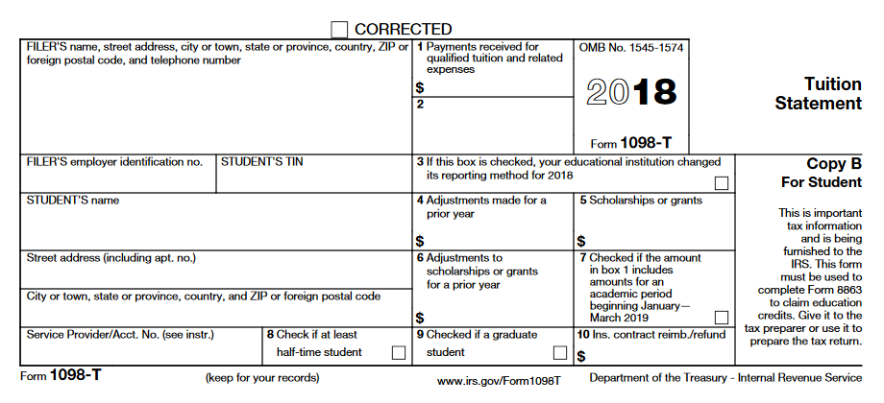

Mary Schumacher, Bursar
Morgan Hall
1700 SW College Avenue
Topeka, KS 66621
(785) 670-1156

